**Full Stack Development with MERN**

**Frontend Development Report**

|  |  |
| --- | --- |
| Date | 18th July,2024 |
| Team ID | SWTID1720110658 |
| Project Name | BookNest |
| Maximum Marks | 100 |

**Project Title:BookNest**

Date:18th July,2024

Prepared by: Shreya Agarwal (TEAM LEADER) 22BCE2179

Monesha Ra 22BPS1190  
 Venu Gopal 22BCE2829  
 Anisha Plawat 22BCE0275

**Objective**

The objective of this report is to document the frontend development progress and key aspects of the user interface implementation for the BookNest project.

**Technologies Used**

* **Frontend Framework:** React.js
* **State Management:** React Redux
* **UI Framework/Libraries:** [Tailwind, Bootstrap]
* **API Libraries:** firebase , React Router , fetch API

**Project Structure**

**HOME PAGE :**





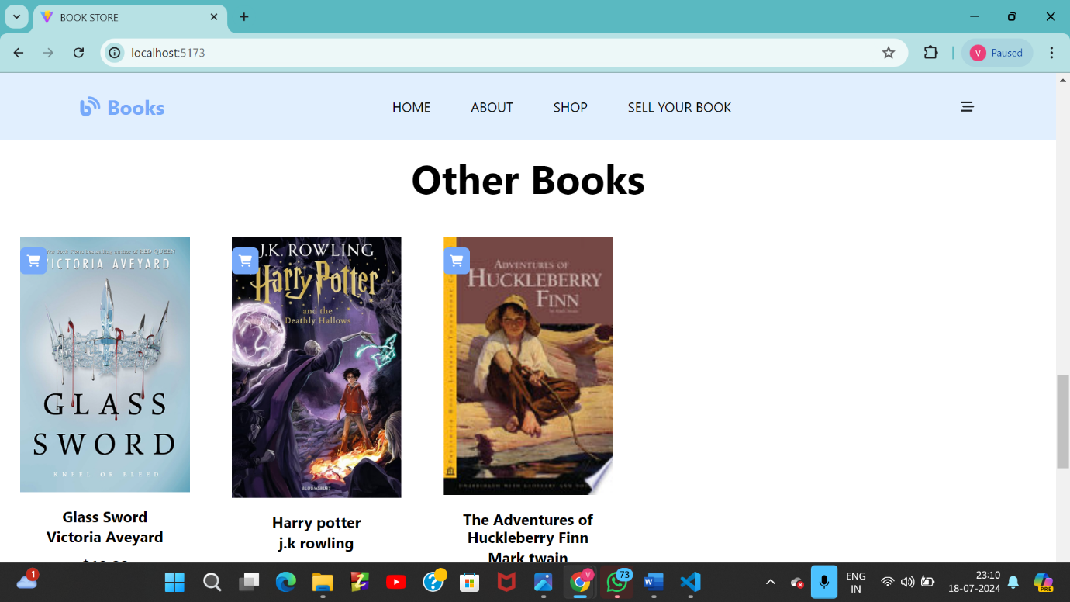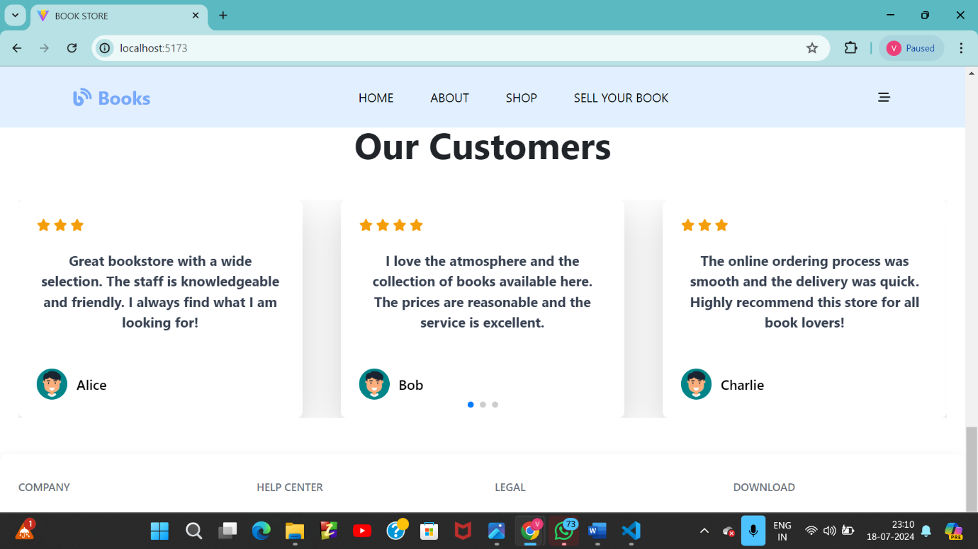

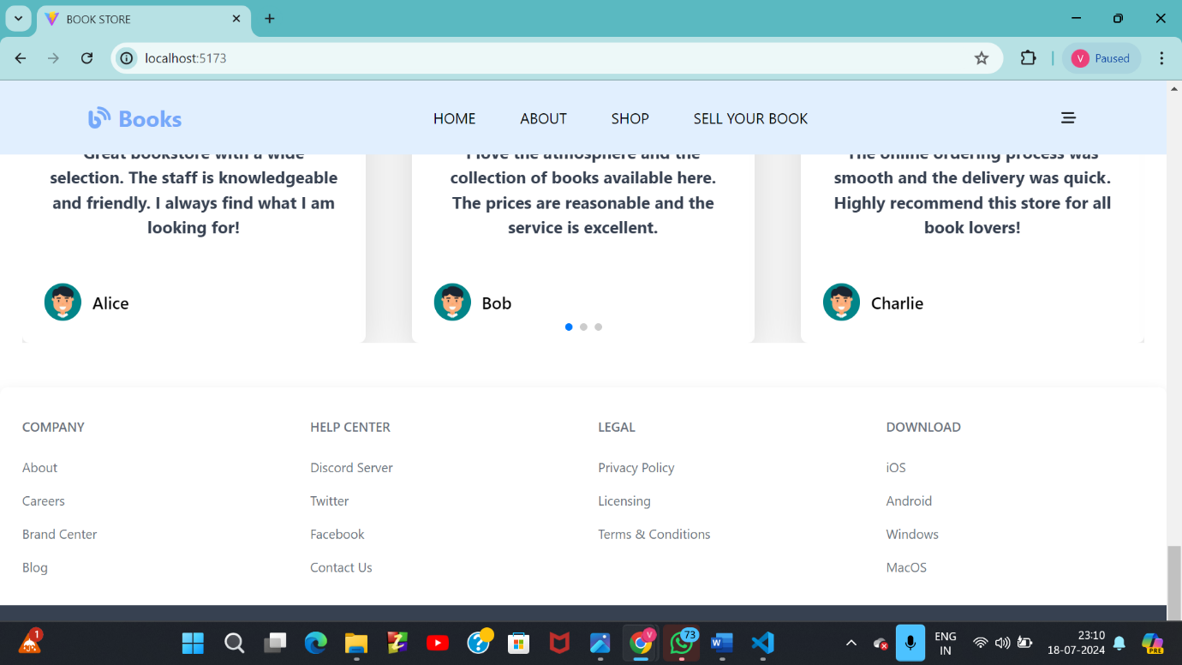

ABOUT PAGE:

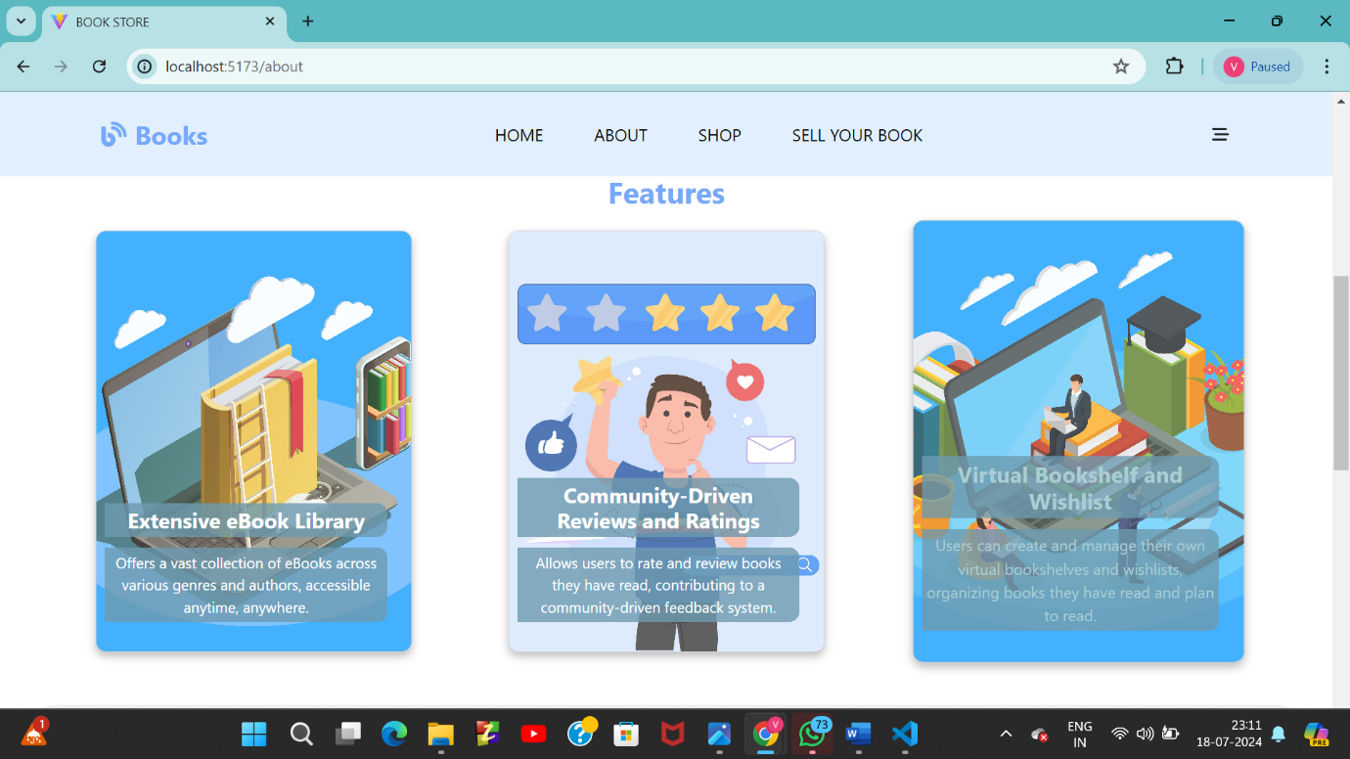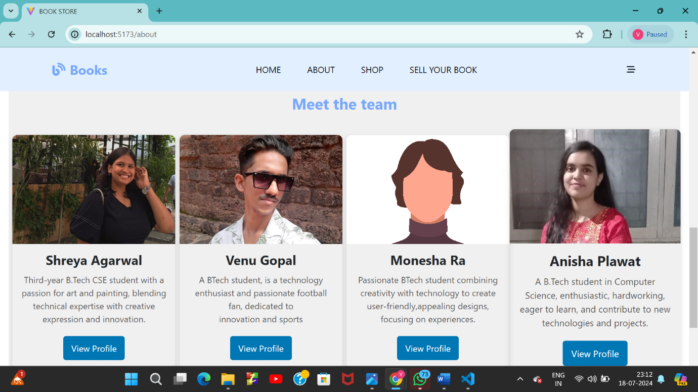

SHOP PAGE:

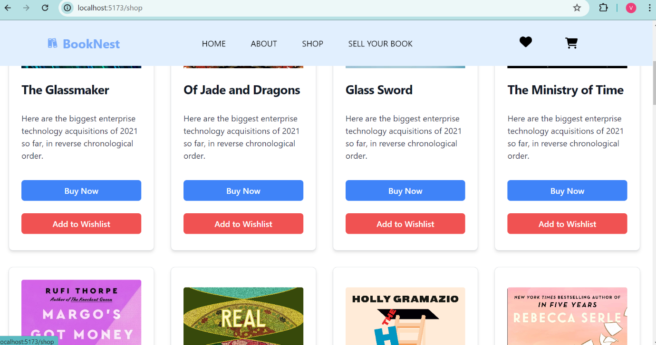

On clicking:

1>Add to Wishlist

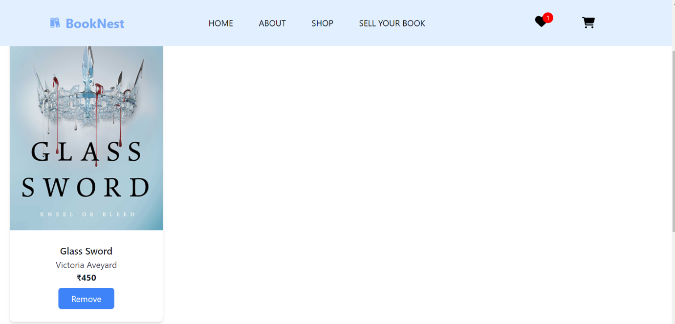

2>Buy Now

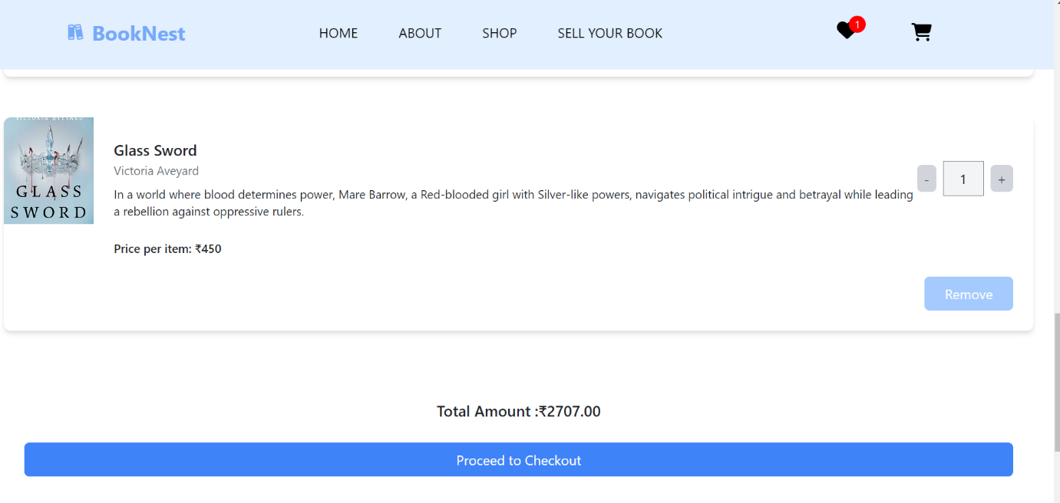

SELL YOUR BOOK:

Not signed in already:

1>Continue with google

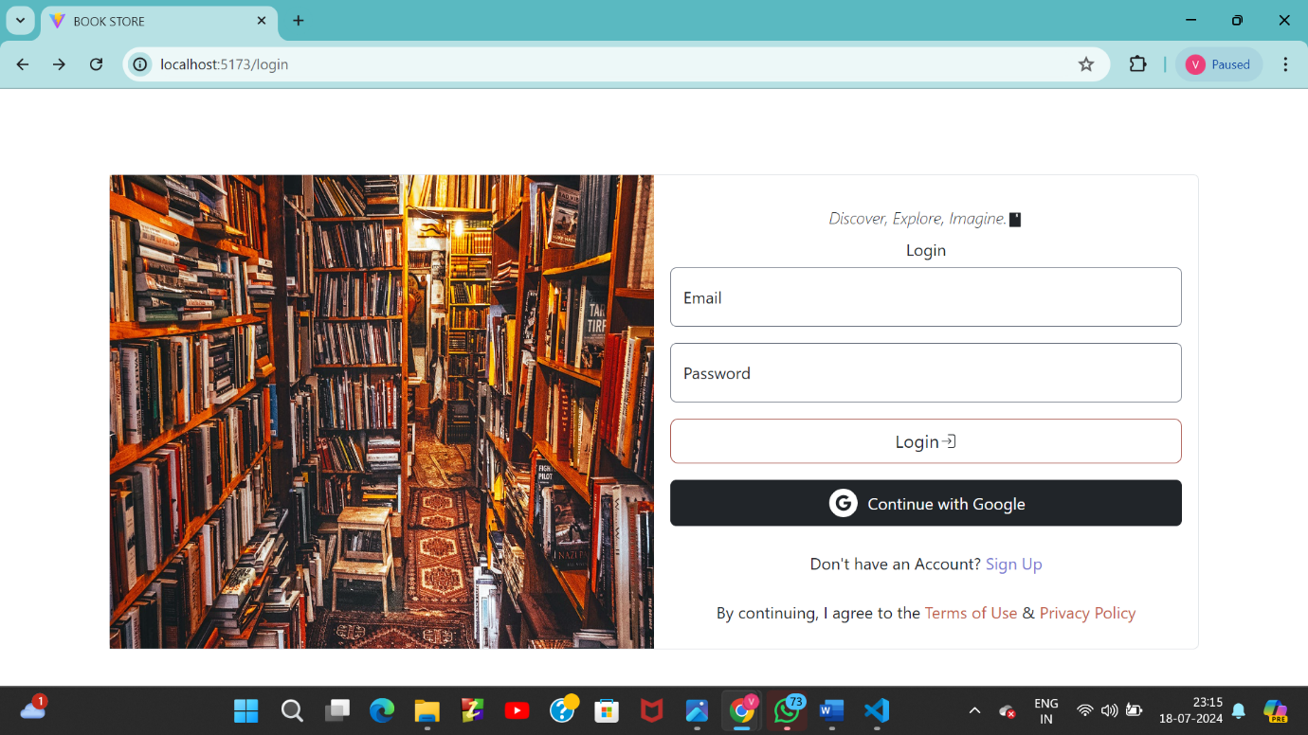

2>Sign up

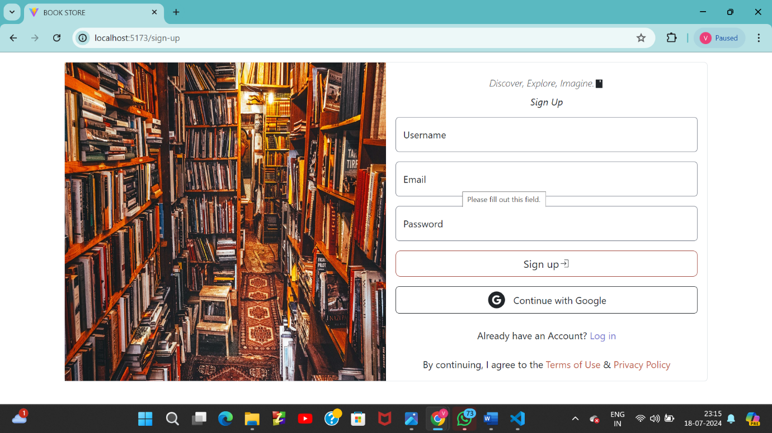

After Signing in:

*Login

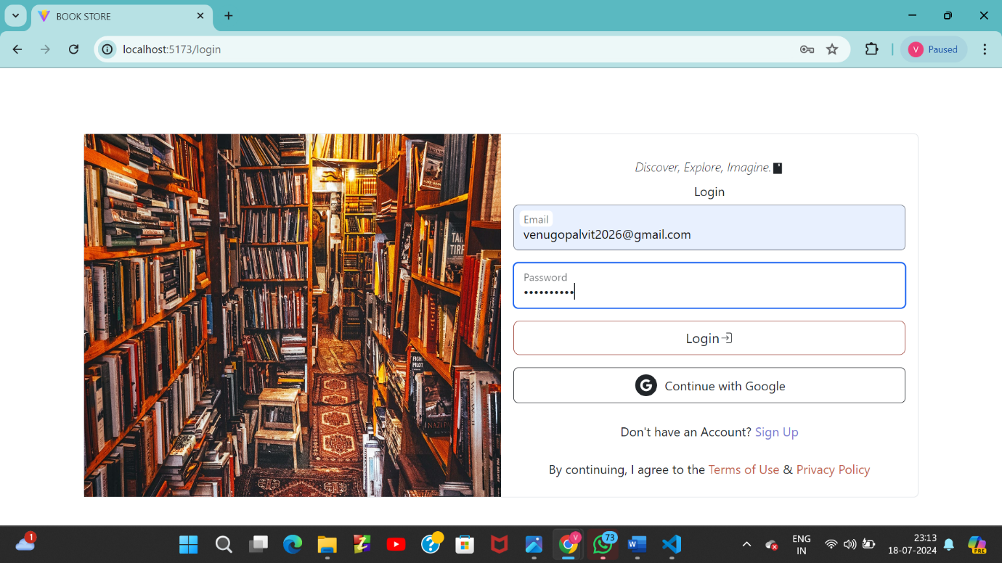

*After Login:

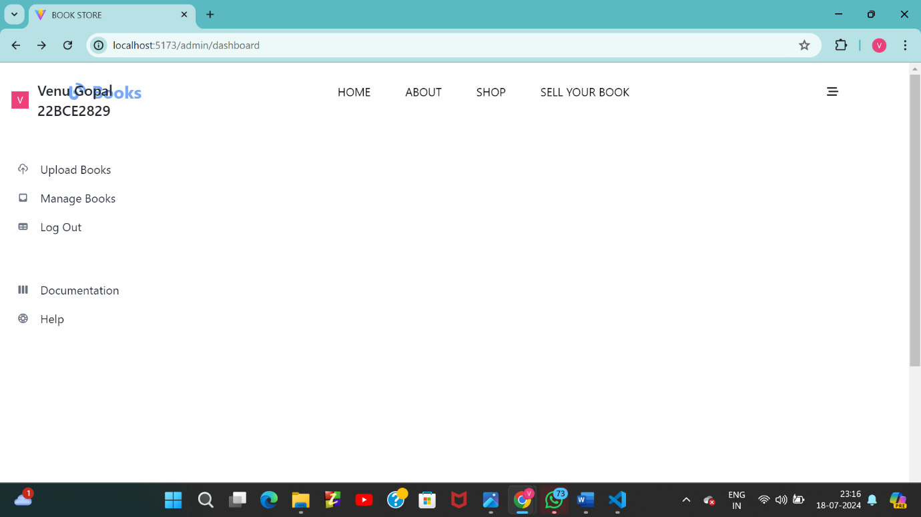

*Manage books:

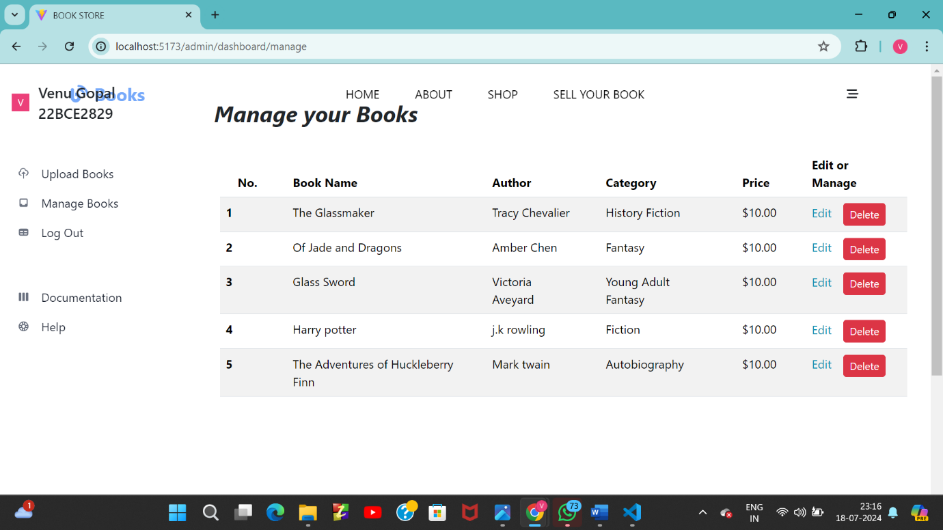

*Upload Books

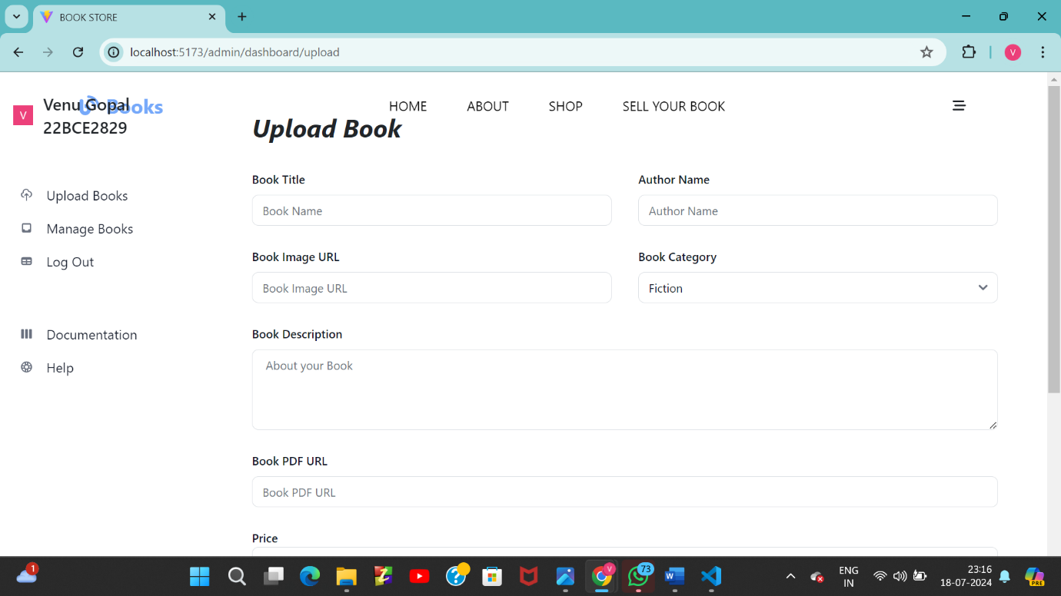

**Key Components**

1. **App.js**
   * Responsible for routing and main application layout.
2. **/components**
   * Contains reusable UI components used across the application.
3. **/assets**
   * Contains assets like images used across the application
4. /dashboard
   * Maintains dashboard across the application
5. /home
   * Contains all contents of home page ;acting as a main thread.

**Routing**

Routing is managed using React Router. Here are the main routes:

• **Root Route (/)**:

* **Path**: "/"
* **Element**: <App />
* **Children**:
  + /home- Landing page of the application.
  + /shop
  + /about
  + /book/:id
  + /admin/dashboard

• **Nested Routes under /admin/dashboard**:

* /admin/dashboard- Dashboard displaying user data and statistics.
* /admin/dashboard/upload
* /admin/dashboard/manage
* /admin/dashboard/edit-books/:id

**Additional Routes**:

* /sign-up
* /login

**State Management (If Applicable)**

State management is achieved using React Redux.

**Integration with Backend**

The frontend communicates with the backend APIs hosted on localhost:5000. Key endpoints include

• **GET /api/data**

* **Purpose**: Retrieves data for display, likely used in various parts of the application such as the home page (/home), shop page (/shop), and about page (/about).
* **Usage**: Typically used to fetch static or dynamic content from the backend.

• **POST /api/user/login**

* **Purpose**: Handles user authentication.
* **Usage**: Used when a user logs in through the login page (/login).

• **GET /book/**

* **Purpose**: Retrieves details of a specific book.
* **Usage**: Used in the route /book/:id, where :id is dynamically replaced with the book's identifier. This endpoint is likely called in the loader function of <SingleBook /> component.

• **GET /api/admin/dashboard**

* **Purpose**: Retrieves data for the admin dashboard.
* **Usage**: Used in the route /admin/dashboard, particularly within the <DashBoard /> component rendered inside <PrivateRoute />.

• **POST /api/admin/dashboard/upload**

* **Purpose**: Uploads a new book to the system.
* **Usage**: Used in the route /admin/dashboard/upload, where <UploadBook /> component handles the upload functionality.

• **GET /api/admin/dashboard/manage**

* **Purpose**: Retrieves the list of managed books for admin.
* **Usage**: Used in the route /admin/dashboard/manage, where <ManageBooks /> component lists and manages books.

• **GET /api/admin/dashboard/edit-books/**

* **Purpose**: Retrieves details of a specific book for editing.
* **Usage**: Used in the route /admin/dashboard/edit-books/:id, where :id is dynamically replaced with the book's identifier. This endpoint is likely called in the loader function of <EditBooks /> component.

**User Interface (UI) Design**

* The UI design follows :

• **Component-Based Architecture**: The project likely follows a component-based architecture where UI elements are encapsulated into reusable components (App, Home, Shop, About, SingleBook, DashBoardLayout, etc.). This promotes code reusability and maintainability.

• **Responsive Design**: React applications often incorporate responsive design principles, ensuring that the user interface adapts well to different screen sizes and devices. Libraries like tailwindcss or Bootstrap might be used for responsive styling.

• **Routing and Navigation**: Navigation between different sections of the application is managed using react-router-dom, providing a seamless user experience as users navigate between pages (/, /shop, /about, /book/:id, /admin/dashboard, etc.).

• **UI Framework or Library**: The use of UI frameworks or libraries such as tailwindcss, Bootstrap, or custom CSS stylesheets can dictate the overall look and feel of the application. These tools often provide pre-styled components and utilities to streamline UI development.

• **Material Design Principles**: If using Material-UI or similar UI libraries, the project might adhere to Material Design principles, focusing on clean, minimalist design, consistent use of colors, typography, and motion.

• **User Experience (UX) Considerations**: Consideration for user experience might include intuitive navigation, clear calls to action, feedback mechanisms for user interactions (like form submissions or API requests), and error handling.

.

* Implemented using Tailwind,Bootstrap.

**Third-Party Integrations (If any)**